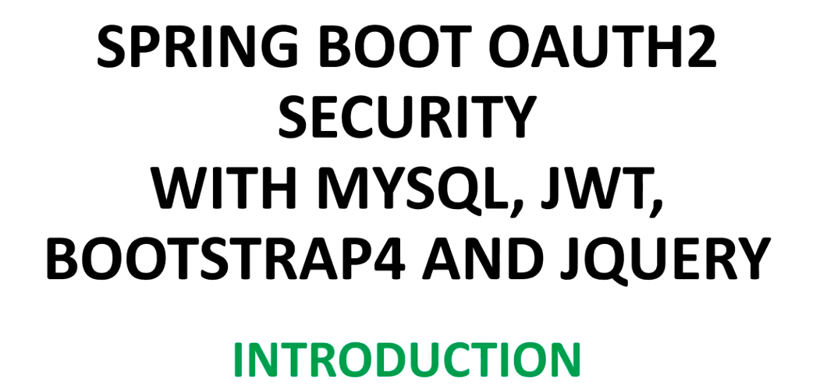

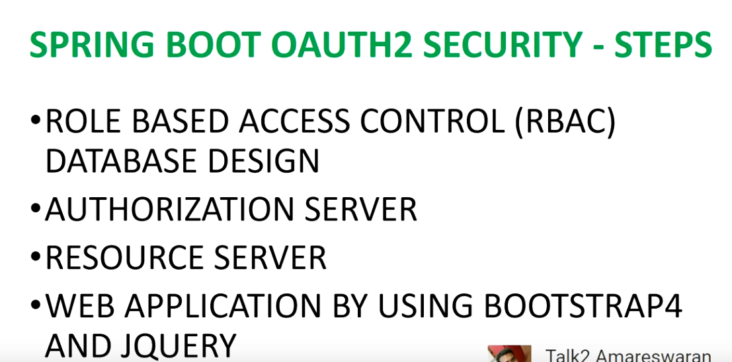

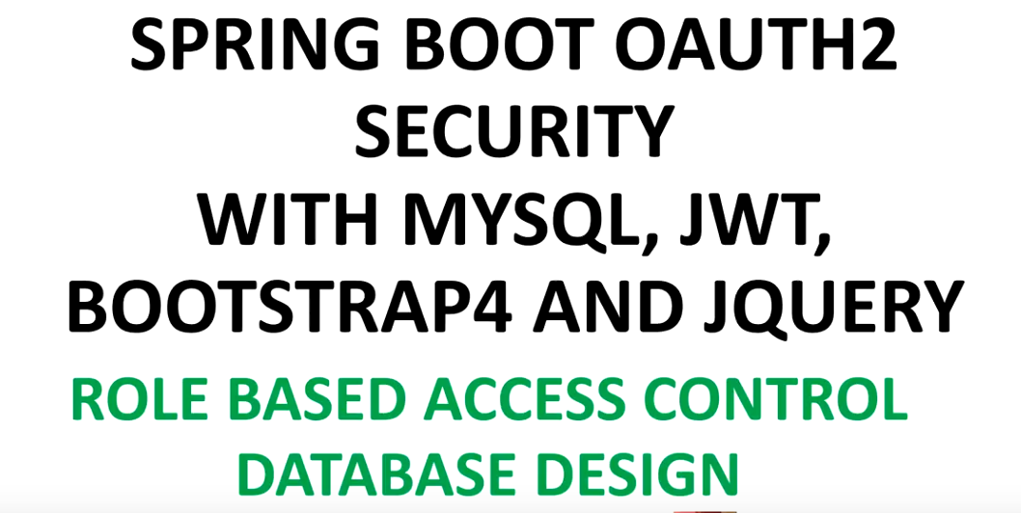

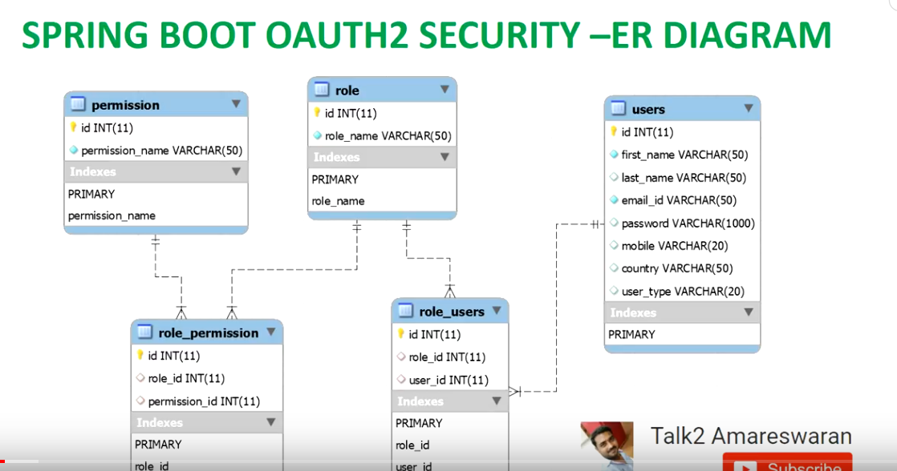

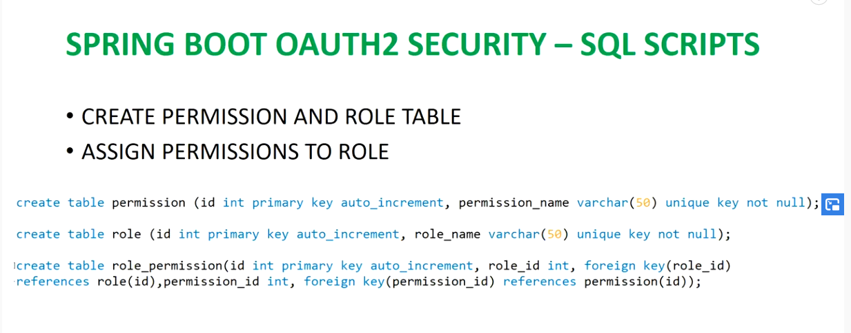

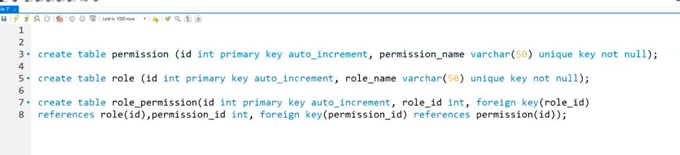

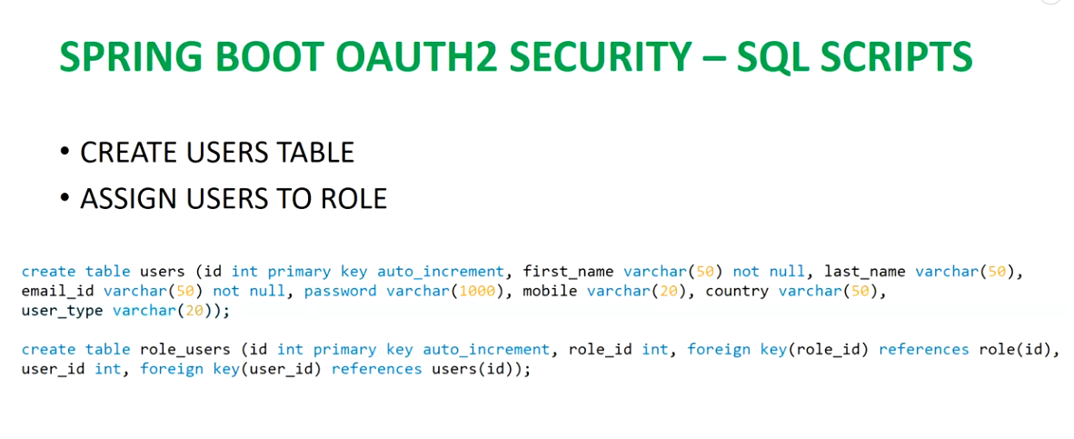

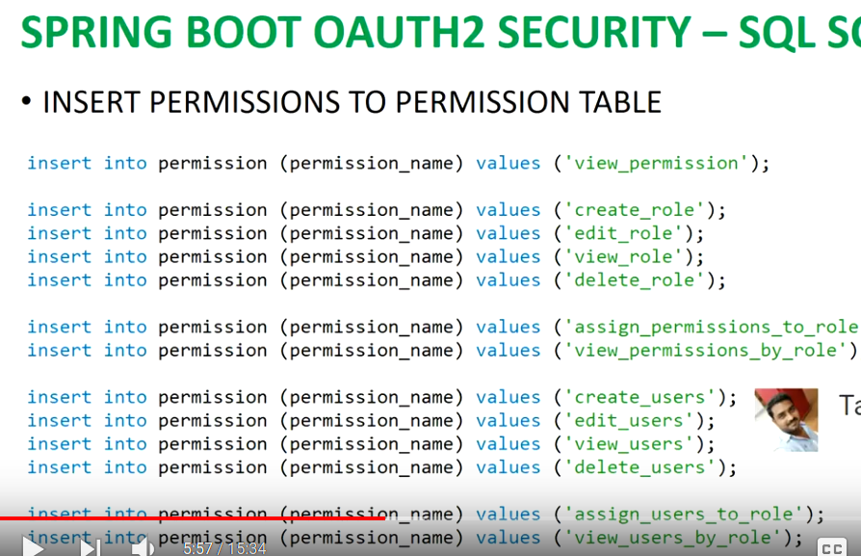

insert into permission (id,permission_name) VALUES (nextval('hibernate_sequence'),'view_permission');

insert into permission (id,permission_name) VALUES (nextval('hibernate_sequence'),'create_role');

insert into permission (id,permission_name) VALUES (nextval('hibernate_sequence'),'edit_role');

insert into permission (id,permission_name) VALUES (nextval('hibernate_sequence'),'view_role');

insert into permission (id,permission_name) VALUES (nextval('hibernate_sequence'),'delete_role');

insert into permission (id,permission_name) VALUES (nextval('hibernate_sequence'),'assign_permission_to_role');

insert into permission (id,permission_name) VALUES (nextval('hibernate_sequence'),'view_permission_by_role');

insert into permission (id,permission_name) VALUES (nextval('hibernate_sequence'),'create_user');

insert into permission (id,permission_name) VALUES (nextval('hibernate_sequence'),'edit_user');

insert into permission (id,permission_name) VALUES (nextval('hibernate_sequence'),'view_user');

insert into permission (id,permission_name) VALUES (nextval('hibernate_sequence'),'delete_user');

insert into permission (id,permission_name) VALUES (nextval('hibernate_sequence'),'assign_user_to_role');

insert into permission (id,permission_name) VALUES (nextval('hibernate_sequence'),'view_user_by_role');

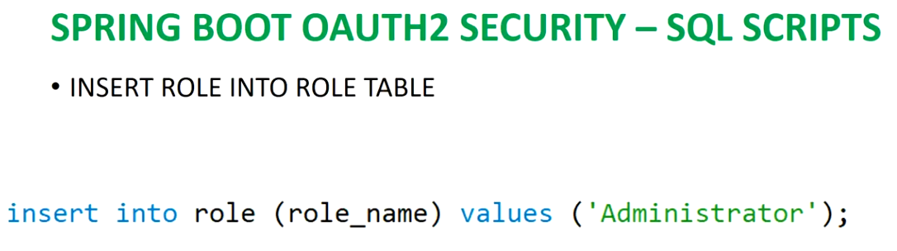

insert into role (id,role_name) VALUES (nextval('hibernate_sequence'),'Administrator');

insert into role_permission (id,role_id,permission_id) VALUES (nextval('hibernate_sequence'),14,1);

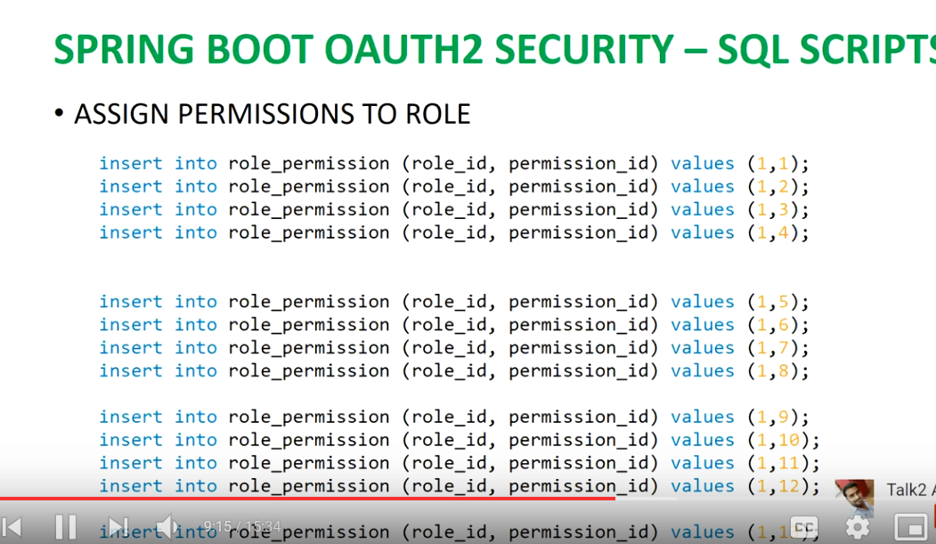

insert into role_permission (id,role_id,permission_id) VALUES (nextval('hibernate_sequence'),14,2);

insert into role_permission (id,role_id,permission_id) VALUES (nextval('hibernate_sequence'),14,3);

insert into role_permission (id,role_id,permission_id) VALUES (nextval('hibernate_sequence'),14,4);

insert into role_permission (id,role_id,permission_id) VALUES (nextval('hibernate_sequence'),14,5);

insert into role_permission (id,role_id,permission_id) VALUES (nextval('hibernate_sequence'),14,6);

insert into role_permission (id,role_id,permission_id) VALUES (nextval('hibernate_sequence'),14,7);

insert into role_permission (id,role_id,permission_id) VALUES (nextval('hibernate_sequence'),14,8);

insert into role_permission (id,role_id,permission_id) VALUES (nextval('hibernate_sequence'),14,9);

insert into role_permission (id,role_id,permission_id) VALUES (nextval('hibernate_sequence'),14,10);

insert into role_permission (id,role_id,permission_id) VALUES (nextval('hibernate_sequence'),14,11);

insert into role_permission (id,role_id,permission_id) VALUES (nextval('hibernate_sequence'),14,12);

insert into role_permission (id,role_id,permission_id) VALUES (nextval('hibernate_sequence'),14,13);

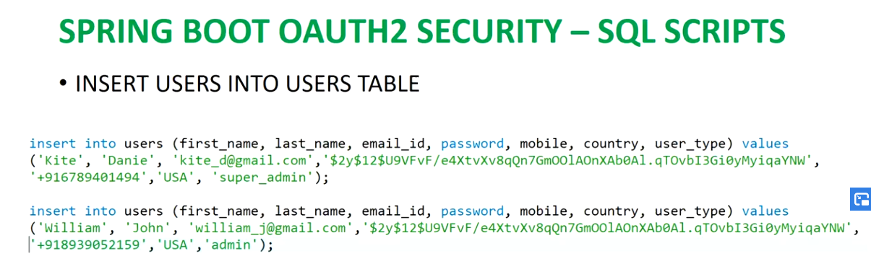

insert into users (id,first_name,last_name,email_id,password,mobile,country,user_type) VALUES (nextval('hibernate_sequence'),

'sachin','hs','sachin.hs@bcits.in','password' ,'9035997204','India','super_admin');insert into users (id,first_name,last_name,email_id,password,mobile,country,user_type) VALUES (nextval('hibernate_sequence'),

'sachin','gowda','sachin19927@gmail.com','password' ,'9035997204','India','admin');

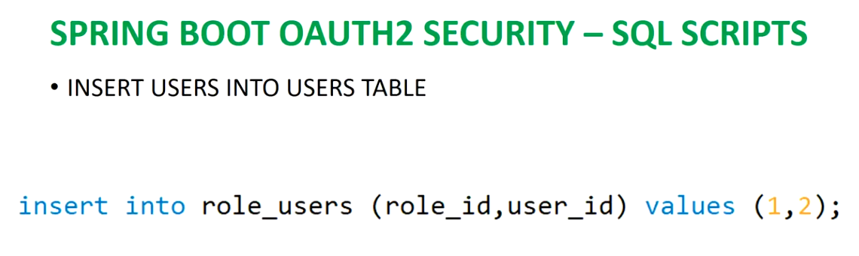

insert into role_users (id,role_id,user_id) VALUES (nextval('hibernate_sequence'),14,31);

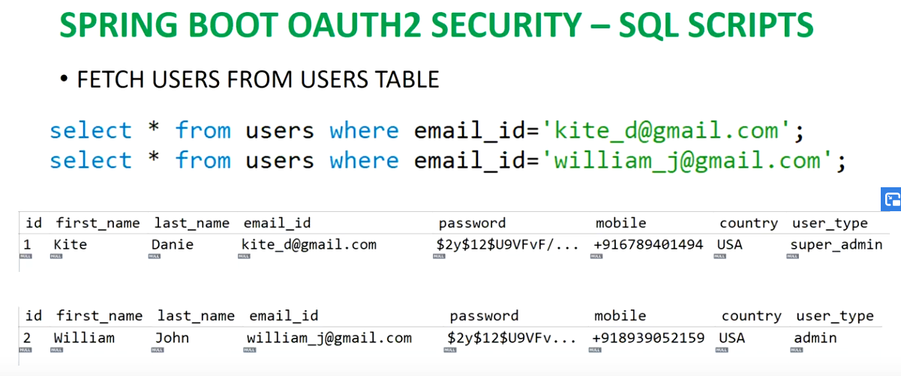

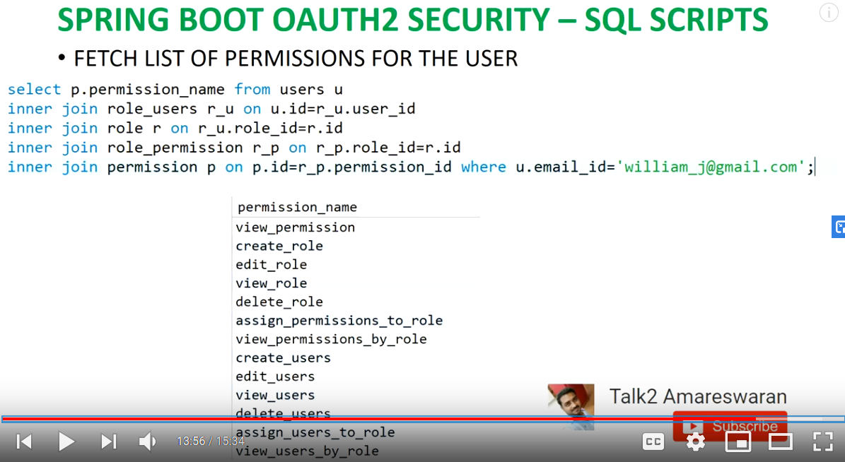

select p.permission_name from users u

INNER JOIN role_users r_u on u.id=r_u.user_id

INNER JOIN role r on r_u.role_id=r.id

INNER JOIN role_permission r_p on r_p.role_id=r.id

INNER JOIN permission p on p.id=r_p.permission_id where [u.email_id='sachin19927@gmail.com'](mailto:u.email_id='sachin19927@gmail.com')

